**Math 120  
2.3 Complex Numbers**

# **Objectives:**

1. Add and subtract complex numbers
2. Multiply complex numbers
3. Divide complex numbers
4. Perform operations with square roots of negative numbers

# **Topic #1: The Imaginary Unit and Complex Numbers**

Recall that the domain for the square root function must be a non-negative number; _________



However, the domain is a discussion about **Real Numbers**. Here we will look at the **______________** and **____________________**



Consider the expression ; it is not defined by the real number system. However, expressions like this show up in mathematics and a new number system helps us deal with them.



***The Imaginary Unit***

The imaginary unit is defined as __________________ For example, we can use the unit to rewrite undefined numbers: _____________________________________



The result is a pure imaginary number.

The imaginary unit is the basis for the complex number system and also the solution to the equation . In other words, .

***The Complex Number System***

Complex numbers have two parts – a real part and an imaginary part.

They are in the form _______________________



where is the real part and is the imaginary part.

**The conjugate of is** .



*Example #1* – Identify the Real and Imaginary Part of the Complex Number

a.



b.



c.



# **Topic #2: Operations on Complex Numbers**

***Addition and Subtraction***

Adding or subtracting two complex numbers produces a new complex number.

Consider the complex numbers:

They can be added by combining like parts:



They can be subtracted by distributing and combining like parts:



In both cases, a new complex number results!

***Multiplication (FOIL)***

Multiplying has the same effect; two complex numbers multiply to create a new one.

Consider the complex numbers:

They can be multiplied by using the distributive property/FOIL:

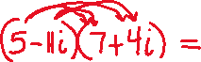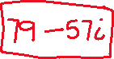

*YOU TRY #1* – Perform the Operation and Write Result in Standard Form







FOIL, rewrite , and combine like parts:



d.



FOIL, rewrite , and combine like parts:



Notice the imaginary parts cancelled, this ALWAYS happens when multiplying conjugates: and . **The useful formula for multiplying conjugates is**



e.

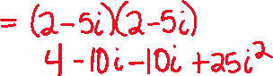

f.

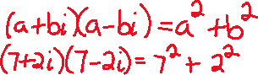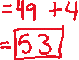

# **Topic #3: Operations on Complex Numbers – Division**

Besides addition, subtraction, and multiplication, we can also divide one complex number into another. The result gives a new complex number.

Consider the complex numbers:

Suppose we want to divide the first number by the second:



To do this, we can multiply both the numerator and denominator by the _________________ of the denominator;



**we do this to create a real number divisor:**

This will make the imaginary part of the complex number in the denominator go away

Since

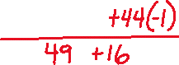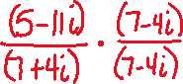

Technically this is not in form, so split up the fraction:



It is good to understand the process of introducing a conjugate to do the division, but feel free to use a graphing calculator to double check:

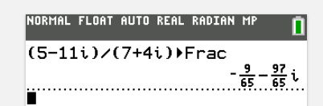

*Example #1* – Perform the Division and Write Result in Standard Form

Multiply both the numerator and denominator by the conjugate of the denominator:

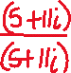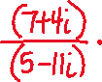

FOIL, combine like terms (feel free to use the conjugate formula for the denominator), and split up the fraction:

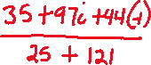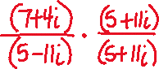

Multiply both the numerator and denominator by the conjugate of the denominator:

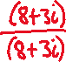

Distribute, combine like terms (feel free to use the conjugate formula for the denominator), and split up the fraction:



Feel free to check answers with the calculator. The most useful idea here is that multiplying two conjugate complex numbers will remove the imaginary part!

*YOU TRY #2* - Perform the Division and Write Result in Standard Form

1. b.

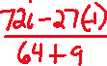

# **Topic #4: Operations on Square Roots with Negative Numbers**



As stated before, square roots with negative numbers are undefined with the real number system. However, they are defined with the complex number system.

***To operate, the undefined real numbers are converted to defined complex numbers*** and we proceed with the rules established earlier.

The principal square root of a negative number is defined as:



, where and ________

*Example #1* – Convert, Perform the Operation, and Write Result in Standard Form

a. b.



c.



d.



e.

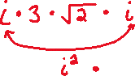

f.

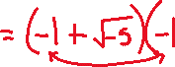

g.



*YOU TRY #3* - Convert, Perform the Operation, and Write Result in Standard Form

1. b.



C.

